

**Institute of Engineering & Technology**

|  |
| --- |
| **MINI PROJECT REPORT**  **On**  **LIBRARY MANAGEMENT SYSTEM**  **Submitted by**  **Pravendra Kumar**  **171500236**  **Department of Computer Engineering & Applications Institute of Engineering & Technology**    **GLA University**  **Mathura- 281406, INDIA 2020** |

|  |  |  |
| --- | --- | --- |
|  | |  | | --- | | **Department of computer Engineering and ApplicationsGLA University, Mathura**  **17 km. Stone NH#2, Mathura-Delhi Road, P.O. – Chaumuha,**  **Mathura – 281406** | |

**Declaration**

We hereby declare that the work which is being presented in the Mini project “LIBRARY MANAGEMENT SYSTEM”, in partial fulfillment of the requirements for project viva voice, is an authentic record of my own work carried under the supervision of our mentor **Mr. AMIR KHAN** sir.

Pravendra Kumar

171500236

B.tech(CSE)

3rd Year

Vth Semester

# ACKNOWLEDGEMENT

It is indeed with a great pleasure and immense sense of gratitude that we acknowledge the help of these individuals. We are highly indebted to our Mentor **Mr. AMIR KHAN** for the facilities provided to accomplish this mini project.

We would like to thank our mentor for this constructive criticism throughout our project. We extremely grateful to our Departmental staff members, Lab technicians and Non-teaching staff members for their extreme help throughout our project.

Finally, we express our heartful thanks to all of our professors who helped us in successful completion of this project .

# ABSTRACT :

The purpose of the project entitled as “Library Management System ” is to compute the Office Management of System to develop software which is user to secure. It deals with the collection of Books or collect information. Traditionally, it was done manually. The main function of the system is register and store books details and student reviews and retrieve these details as and when required, and also to manipulate these details meaningfully . The Library Management System can be entered using a username and password. It is accessible either by an administrator . Only they can add data into the database. The data can be retrieved easily. The data are well protected for personal use and makes the data processing very fast.

|  |  |  |
| --- | --- | --- |
| **S.NO**  **.** | **TABLE OF CONTENTS** | **PAGE NO.** |
| **1** | INTRODUCTION | **1** |
| **1.1** | Introduction | **1** |
| **1.2** | Problem introduction | **1** |
| **1.3** | Modules in the project | **2** |
| **2** | REQUIREMENTS SPECIFICATION | **4** |
| **2.1** | 2.1 Introduction | **4** |
| **2.2** | Hardware requirements | **4** |
| **2.3** | Software requirements | **5** |
| **3** | ANALYSIS | **6** |
| **3.1** | Existing System | **6** |
| **3.2** | Feasibility study | **6** |
| **3.3** | Software specification | **8** |

|  |  |  |
| --- | --- | --- |
| **4** | DESIGN | **10** |
| **4.1** | System Design | **10** |
| **4.1.1** | Introduction to UML | **10** |
| **4.1.2** | UML Diagrams | **12** |
| **5** | IMPLEMENTATION | **15** |
| **6** | INTRODUCTION TO SYSTEM TESTING | **30** |
| **7** | PROJECT SCREENSHOTS | **35** |

## INTRODUCTION

**1.1 Introduction:**

The main objective of the Library Management system is organizing and managing the library tasks. Library is place where all kind of books are available. This is a web base application and only a registered user can access the application. Library Management system is developed to automate the task of entering the records of new book and retrieving the details of book available in the library. This system contains list of all the books. Using this system user can issue book to the library member, maintain their records, and can checks how many book are issued and how many books are available in the library. This system provides separate interface and login for librarian, students and faculties. Librarian can modify database. Using the library management system, user can also maintain the late fine of library member who return the issued book after the due date.  
  
Users can search for books and renewal books online. In the proposed system, we assume that each member will be having a identity card which can be used for the library book issue, fine payment etc. They can recommend for new books by just sending messages to the librarian from any where in the college. whenever library member wish to take a book, the book issued by the library authority will be check both the book details as well as the student details and store it in library database. They can view the issue and return dates of any book and due they have to pay.

**Objective:-**

1. The aims and objectives are as follows:  
  
2. Online book issue. Improvement in control and performance  
  
3. Request column for librarian for providing new books. The system is developed to cope up with the current issues and problems of library .The system can add user, validate user.  
  
4. A separate column for digital library. Librarian is able to search record by using few clicks of mouse and few search keywords thus saving his valuable time.  
 **1.3 MODULES:**

**Admin Module**

[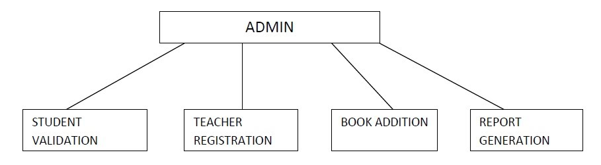](https://sites.google.com/site/ignoubcafinalyearprojects/project-report/library-management-system-project-report/admin%20module%20-%20library%20management%20system.jpg?attredirects=0)

**Student Module**

[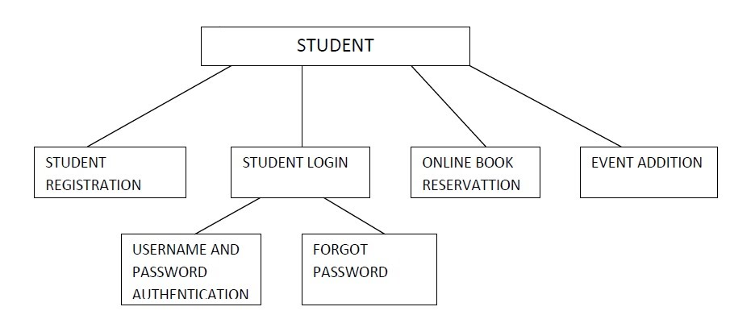](https://sites.google.com/site/ignoubcafinalyearprojects/project-report/library-management-system-project-report/Student%20module%20-%20library%20management%20system.jpg?attredirects=0)

**Book Transaction Module**

[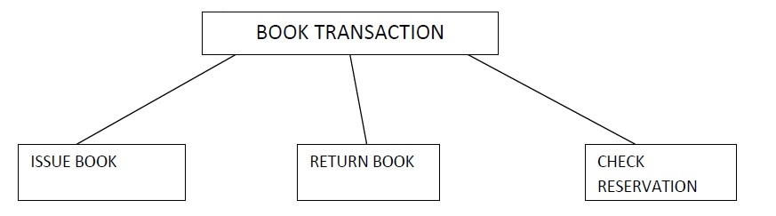](https://sites.google.com/site/ignoubcafinalyearprojects/project-report/library-management-system-project-report/Book%20transaction%20module%20-%20library%20management%20system.jpg?attredirects=0)

## REQUIREMENT SPECIFICATION

**2.1INTRODUCTION:**

To be used efficiently, all computer software needs certain hardware components or the other software resources to be present on a computer. These are known as(computer) system requirements and are often used as a guideline as opposed to an absolute rule. Most software defines two sets of system requirements: minimum and recommended. With increasing demand for higher processing power and resources in newer versions of software, system requirements tend to increase over time. Industry analysts suggest that this trend plays a big part in driving upgrades to existing computer systems than technological advancements.

**2.3SOFTWARE REQUIREMENTS:**

Software Requirements deal with defining software resource requirements that need to be installed on a computer to provide optimal functioning of an application. These requirement prerequisites are generally not included in the software installation package and need to be installed separately before the software is installed.

## ANALYSIS

Feasibility study is conducted once the problem is clearly understood.  Feasibility study is a high level capsule version of the entire system analysis and design process.  The objective is to determine quickly at a minimum expense how to solve a problem.  The purpose of feasibility is not to solve the problem but to determine if the problem is worth solving.

            The system has been tested for feasibility in the following points.

               1. Technical Feasibility

               2. Economical Feasibility

               3. Operational Feasibility.

**1. Technical Feasibility**

 The project entitles "Courier Service System” is technically feasibility because of the below mentioned feature.  The project was developed in Java which Graphical User Interface.

 It provides the high level of reliability, availability and compatibility.  All these make Java an appropriate language for this project.  Thus the existing software Java is a powerful language.

**2. Economical Feasibility**

The computerized system will help in automate the selection leading the profits and details of the organization.  With this software, the machine and manpower utilization are expected to go up by 80-90% approximately.  The costs incurred of not creating the system are set to be great, because precious time can be wanted by manually.

**3. Operational Feasibility**

In this project, the management will know the details of each project where he may be presented and the data will be maintained as decentralized and if any inquires for that particular contract can be known as per their requirements and necessaries.

**3.3 SOFTWARE SPECIFICATION (languages used)**

**Back End:**

**Python:**

Python is an interpreted, object-oriented programming language similar to PERL, that has gained popularity because of its clear syntax and readability. Python is said to be relatively easy to learn and portable, meaning its statements can be interpreted in a number of operating systems, including UNIX-based systems, Mac OS, MS-DOS, OS/2, and various versions of Microsoft Windows 98. Python was created by Guido van Rossum, a former resident of the Netherlands, whose favorite comedy group at the time was Monty Python's Flying Circus. The source code is freely available and open for modification and reuse. Python has a significant number of users.

**TKINTER :**

Python offers multiple options for developing GUI (Graphical User Interface). Out of all the GUI methods, tkinter is most commonly used method. It is a standard Python interface to the Tk GUI toolkit shipped with Python. Python with tkinter outputs the fastest and easiest way to create the **GUI applications Creating a GUI using tkinter is an easy task**.  
**To create a tkinter:**

1. Importing the module – tkinter
2. Create the main window (container)
3. Add any number of widgets to the main window
4. Apply the event Trigger on the widgets.

**IMPLEMENTATION:**

  Implementation is the stage where the theoretical design is turned into a working system. The most crucial stage in achieving a new successful system and in giving confidence on the new system for the users that it will work efficiently and effectively.

The system can be implemented only after thorough testing is done and if it is found to work according to the specification.It involves careful planning, investigation of the current system and its constraints on implementation, design of methods to achieve the change over and an evaluation of change over methods a part from planning. Two major tasks of preparing the implementation are education and training of the users and testing of the systemThe more complex the system being implemented, the more involved will be the systems analysis and design effort required just for implementation.

import tkinter # note that module name has changed from Tkinter in Python 2 to tkinter in Python 3

top = tkinter.Tk()

# Code to add widgets will go here...

top.mainloop()

**Install Python:**

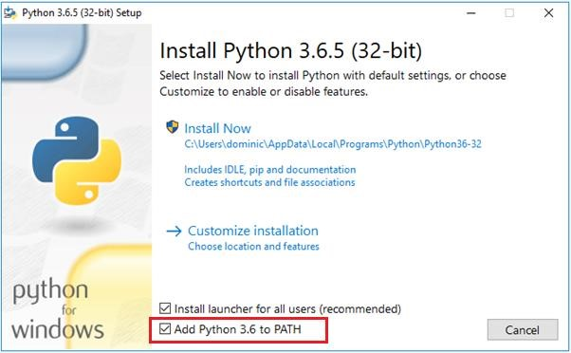

import tkinter # note that module name has changed from Tkinter in Python 2 to tkinter in Python 3

top = tkinter.Tk()

# Code to add widgets will go here...

top.mainloop()

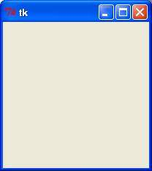

**INTRODUCTION TO SYSTEM TESTING:**

The purpose of testing is to discover errors. Testing is the process of trying to discover every conceivable fault or weakness in a work product. It provides a way to check the functionality of components, sub assemblies, assemblies and/or a finished product It is the process of exercising software with the intent of ensuring that the

Software system meets its requirements and user expectations and does not fail in an unacceptable manner. There are various types of test. Each test type addresses a specific testing requirement.

**TYPES OF TESTING**:

**Unit testing:**

Unit testing involves the design of test cases that validate that the internal program logic is functioning properly, and that program inputs produce valid outputs. All decision branches and internal code flow should be validated. It is the testing of individual software units of the application .it is done after the completion of an individual unit before integration. This is a structural testing, that relies on knowledge of its const ruction and is invasive. Unit tests perform basic tests at component level and test a specific business process, application, and/or system configuration. Unit tests ensure that each unique path of a business process performs accurately to the documented specifications and contains clearly defined inputs and expected results.

**Integration testing:**

Integration tests are designed to test integrated software components to determine if they actually run as one program. Testing is event driven and is more concerned with the basic outcome of scree ns or fields. Integration tests demonstrate that although the components were individually satisfaction, as shown by successfully unit testing, the combination of components is correct and consistent. Integr ation testing is specifically aimed at exposing the problems that arise from the combination of components.

**Functional test:**

Functional tests provide systematic demonstrations that functions tested are available as specified by the business and technical requirements, system documentation, and user manuals.

Functional testing is centered on the following items:

Valid Input : identified classes of valid input must be accepted.

Invalid Input : identified classes of invalid input must be rejected.

Functions : identified functions must be exercised.

Output : identified classes of application outputs must be exercised.

Systems/Procedures: interfacing systems or procedures must be invoked.

Organization and preparation of functional test s is focused on requirements, key functions, or special test cases. In addition, systematic coverage pertaining to identify Business process flows; data fields, predefined processes, and successive processes must be considered for testing. Before functional testing is complete, additional tests are identified and the effective value of current tests is determined.

**System Test**:

System testing ensures that the entire integrated software syst em meets requirements. It tests a configuration to ensure know n and predictable results. An example of system testing is the configuration oriented system integration test. System testing is based on process descriptions and flows, emphasizing pre-driven process links and integration points.

**White Box Testing:**

White Box Testing is a testing in which in which the software tester has knowledge of the inner workings, structure and language of the software, or at least its purpose. It is purpose. It is used to test areas that cannot be reached from a black box level.

**Black Box Testing:**

Black Box Testing is testing the software without any knowledge of the inner workings, structure or language of the module being tested. Black box tests, as most other kinds of tests, must be written from a definitive source document, such as specification or requirements document, such as specification or requirements document. It is a testing in which the software under test is treated, as a black box .you cannot “see” into it. The test provides inputs and responds to outputs without considering how the software works.

**Unit Testing:**

Unit testing is usually conducted as part of a combined code and unit test phase of the software lifecycle, although it is not uncommon for coding and unit testing to be conducted as two distinct phases.

**Test strategy and approach**

Field testing will be performed manually and functional tests will be written in detail.

**Test objectives :**

All field entries must work properly.

Pages must be activated from the identified link.

The entry screen, messages and responses must not be delayed.

**Features to be tested**

Verify that the entries are of the correct format

No duplicate entries should be allowed

All links should take the user to the correct page.

**Integration Testing:**

Software integration testing is the incremental integration testing of two or more integrated software components on a single platform to produce failures caused by interface defects.

The task of the integration test is to check that components or software applications, e.g. components in a software system or – one step up – software applications at the company level – interact without error.

**Test Results:**

All the test cases mentioned above passed successfully. No defects encountered.

**Acceptance Testing:**

User Acceptance Testing is a critical phase of any project and requires significant participation by the end user. It also ensures that the system meets the functional requirements.

**Test Results:**

All the test cases mentioned above passed successfully. No defects encountered.

**PROJECT SCREENSHOTS:**

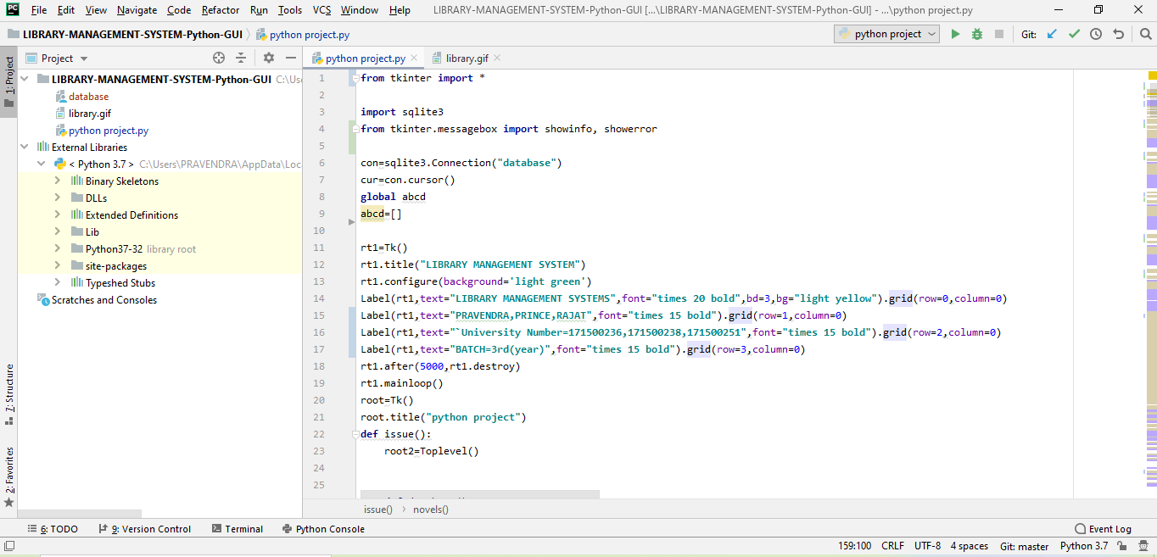

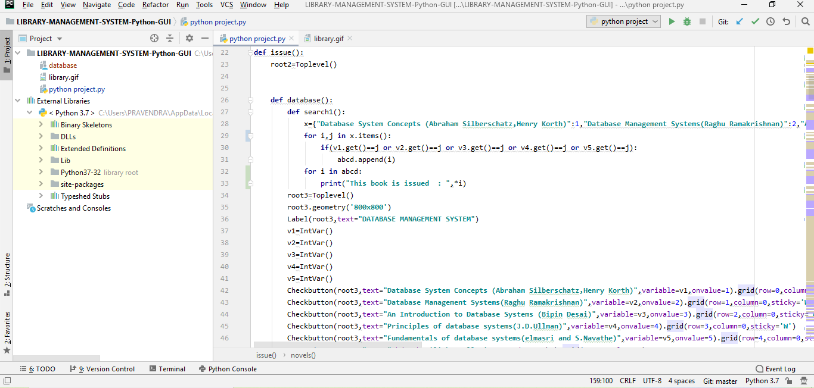

INDES 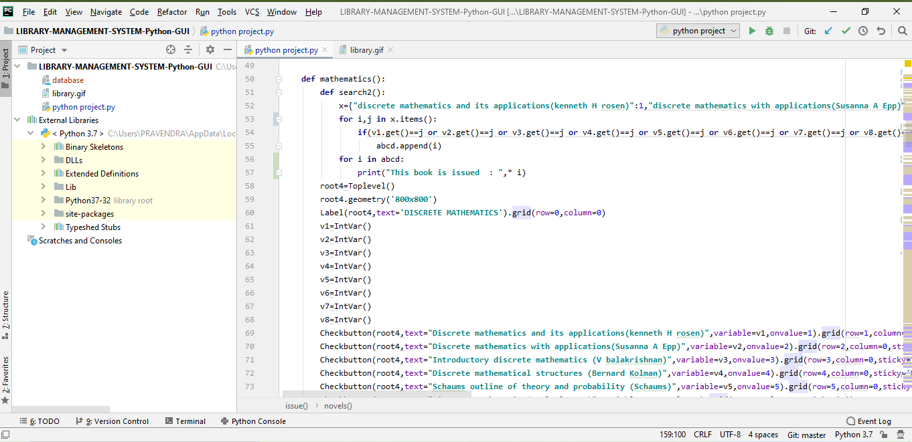

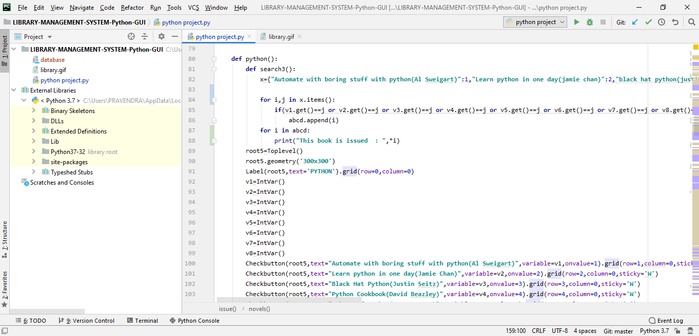

**isy**

**pleasure to acknowledge**

**ct guides, for providing invaluable**

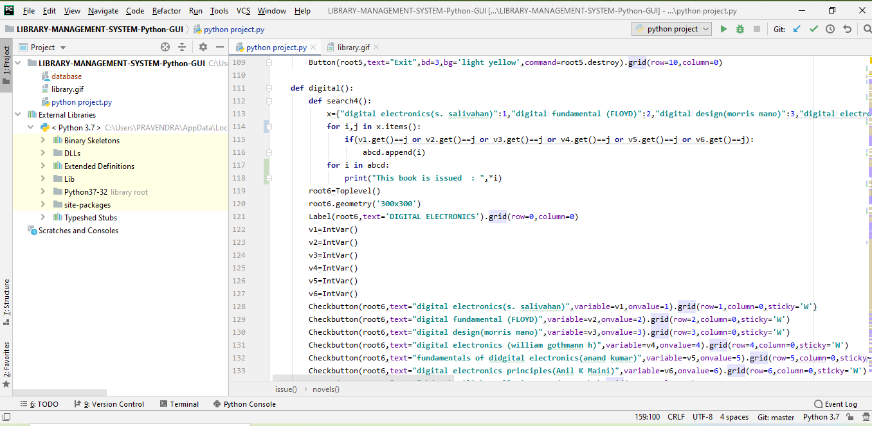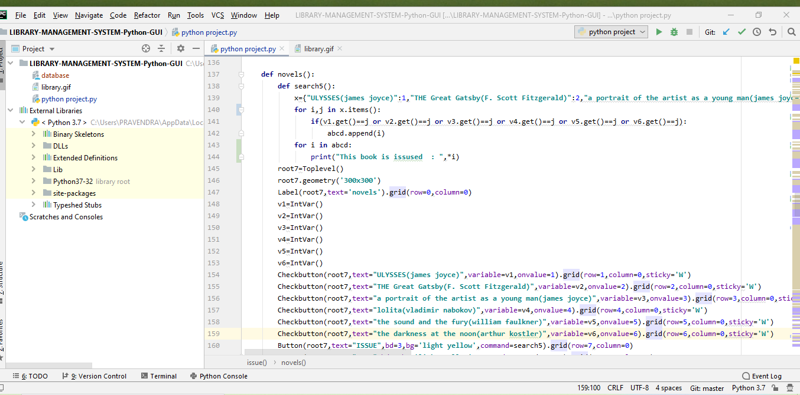

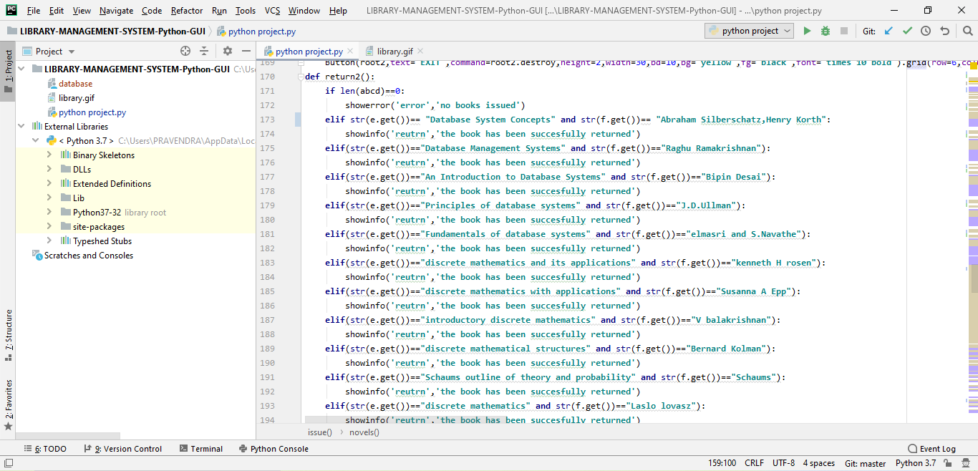

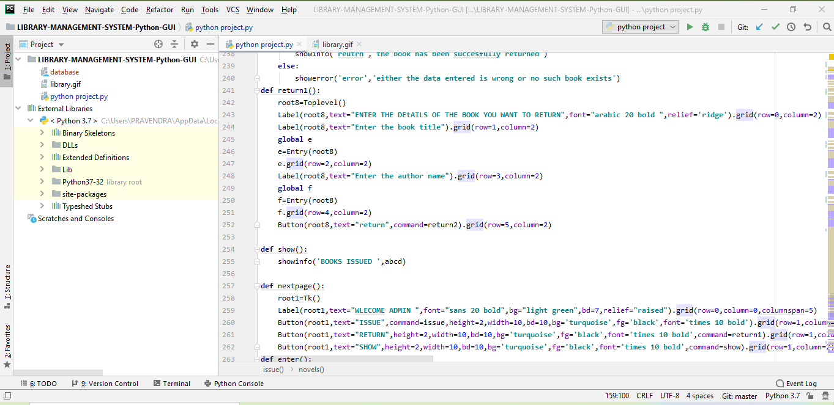

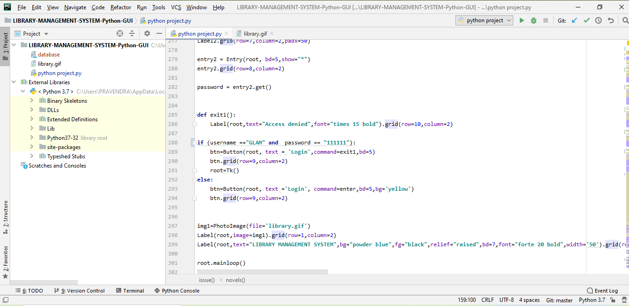

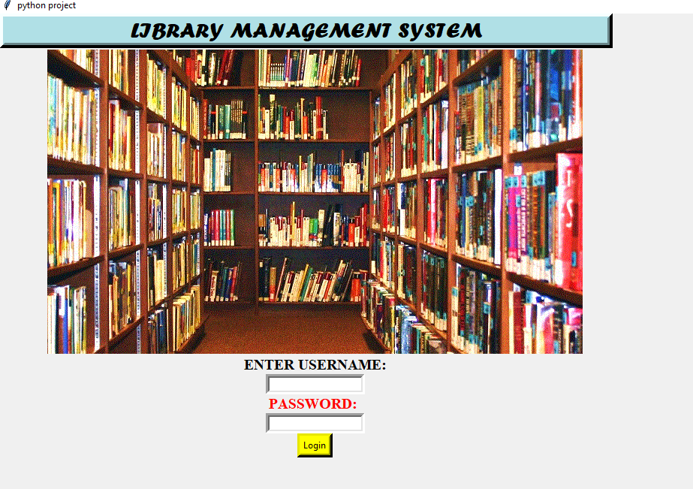

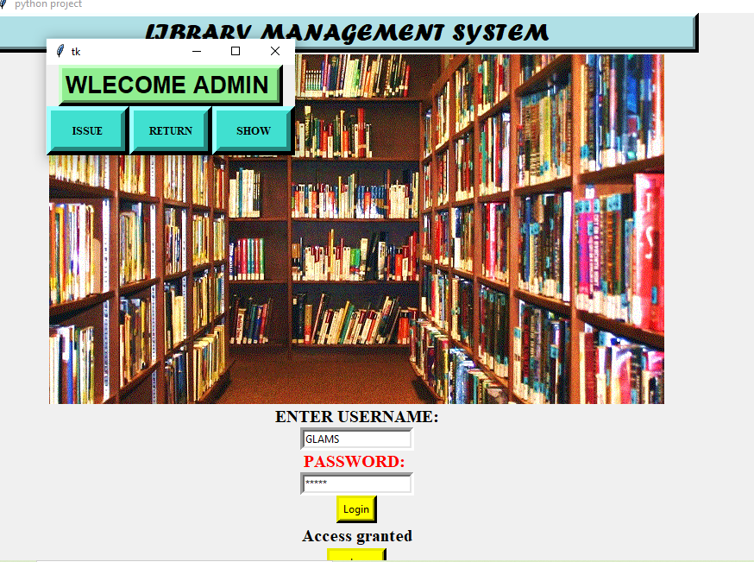

**Bibliography:**

* Stackoverflow.com
* Github.com
* W3school.com
* Youtube.com //Telusko